REDUS Software Collection

# 1 Work Package 1: Fisheries-dependent (catch) surveys and assessment modeling

## 1.1 Library for multi-stage estimation

*Edvin Fuglebakk (IMR)*

*2020-11-01*

Library for design-based estimation and bootstrap estimation from multi-stage sampling designs. Contains functions for estimation from unequal probability sampling, and example data from the Catchlottery-sampling.

**License**: LGPL3

**URL** (*software*): <https://github.com/Sea2Data/CatchLotteryEstimation>

**Keywords**: *multi-stage clustered sampling, design-based estimation, Hansen-Hurwitz, Horvitz-Thompson, hierarchical bootstrap, Poisson sampling*

## 1.2 Prototype for RDBES conversion

*Edvin Fuglebakk (IMR)*

*2020-11-01*

Prototype for RDBES conversion, preparing data for the RDBES test data call in 2020 (Herring and Blue Whiting). Prepares landings and efforts, and samples from catch lottery and other fisheries-targeted sampling (missiontype 1 and 19).

**License**: LGPL3

**URL** (*software*): <https://github.com/edvinf/wkrdb-est-dataconversion>

**Keywords**: *RDBES, catch lottery, test data call 2020*

## 1.3 Reporting functions for StoX-Reca

*Edvin Fuglebakk (IMR)*

*2020-11-01*

Contains functions and example scripts for generating commonly requested reports from StoX-Reca projects (StoX v2.7).

**License**: LGPL3

**URL** (*software*): <https://github.com/Sea2Data/FDAtools/tree/master/stoxReca/reports>

**Keywords**: *Rstox, Reca*

## 1.4 Library for Fisheries Dependent Analysis

*Edvin Fuglebakk (IMR)*

*2020-11-01*

Library for Fisheries Dependent Analysis. Contains a generic interface to Reca, which facilitate adaptation of Reca to many kinds of data formats, and functions for plotting results. Also contains various support functions for fisheries dependent analysis.

**License**: LGPL3

**URL** (*software*): <https://github.com/StoXProject/RstoxFDA>

**Keywords**: *Reca, metier-annotation, landings statistics*

## 1.5 Snapshot-extraction

*Edvin Fuglebakk (IMR)*

*2020-11-01*

Tool for fetching date-versioned data via NMD-biotic API. E.g. Extract the data as it where on a given date in the past.

**License**: LGPL3

**URL** (*software*): <https://github.com/Sea2Data/Dataset-snapshot-extractor>

**Keywords**: *snapshot-extraction, NMDbiotic API*

## 1.6 Coastal cod analysis with Reca

*Edvin Fuglebakk (IMR)*

*2020-11-01*

Contains script for using Rstox and Reca run catch at age estimate for coastal-cod and NEA cod with stock split estimated from otolith-typing, and area definitions incorporating 12-nm delimiter.

**URL** (*software*): <https://github.com/Sea2Data/FDAtools/tree/master/stoxReca/coastalCod>

**Keywords**: *Reca, coastal cod, Rstox*

## 1.7 Reca support in Rstox

*Arne-Johannes Holmin (IMR), Edvin Fuglebakk (IMR)*

*2020-11-01*

Functions for preparing data for Reca and for plotting results and reports

**License**: LGPL3

**URL** (*software*): <https://github.com/Sea2Data/Rstox/tree/develop>

**Keywords**: *Rstox, Reca*

## 1.8 Easy RECA Package

*Ibrahim Umar (IMR), Edvin Fuglebakk (IMR), Hanne W. Rognebakke (NR)*

*2019-05-07*

Reca is a package made for the Institute of Marine Research. The package produces predictions of catch-at-age, i.e. the number of fish caught within each age group, of different fish species. This is a testing version of a universal platform RECA package with OpenBLAS.

**URL** (*software*): <https://github.com/iambaim/new-reca>

**Keywords**: *ECA, IMR, catch-at-age, prediction, fishery dependent, commercial, estimates*

## 1.9 External covariance matrices in SAM

*Olav Nikolai Breivik (NR) and Anders Nielsen (DTU-aqua)*

*2018-04-24*

External observation covariance matrices can be utilized in SAM. Link to example: <https://github.com/fishfollower/SAM/blob/master/testmore/nscodcovar/script.R>

**Jupyter notebook**: ([show](https://nbviewer.jupyter.org/urls/redus-imr.github.io/codes/assets/olav-sam_ext_covar.ipynb)) ([download](assets/olav-sam_ext_covar.ipynb))

**URL** (*software*): <https://github.com/fishfollower/SAM/blob/master/testmore/nscodcovar/script.R>

## 1.10 Prediction variance link used in NEA haddock assessment

*Olav Nikolai Breivik (NR), Anders Nielsen (DTU-aqua) and Casper W. Berg (DTU-aqua)*

*2020-03-19*

A prediction-variance relation was adopted for the official assessment of North East Arctic haddock in 2020. Link to example of code for using that relation in SAM is provided here: <https://github.com/fishfollower/SAM/blob/master/testmore/neaHaddockPredVar/script.R>

**Jupyter notebook**: ([show](https://nbviewer.jupyter.org/urls/redus-imr.github.io/codes/assets/olav-sam_variance_link.ipynb)) ([download](assets/olav-sam_variance_link.ipynb))

**URL** (*software*): <https://github.com/fishfollower/SAM/blob/master/testmore/neaHaddockPredVar/script.R>

**Related identifiers**: <https://doi.org/10.17895/ices.pub.6050>

# 2 Work Package 2: Fishery-independent (scientific) surveys

## 2.1 Biotic Explorer

*Mikko Vihtakari (IMR), Ibrahim Umar (IMR)*

*2019-07-08*

A Shiny app for examination and manipulation of the Norwegian Maritime Data Center (NMD) standard Biotic xml files as well as the IMR’s Biotic database.

**License**: GPL3

**URL** (*software*): <https://github.com/MikkoVihtakari/BioticExplorer>

**Keywords**: *biotic, NMD, IMR, filter, database, file, marine*

**Screenshots**:

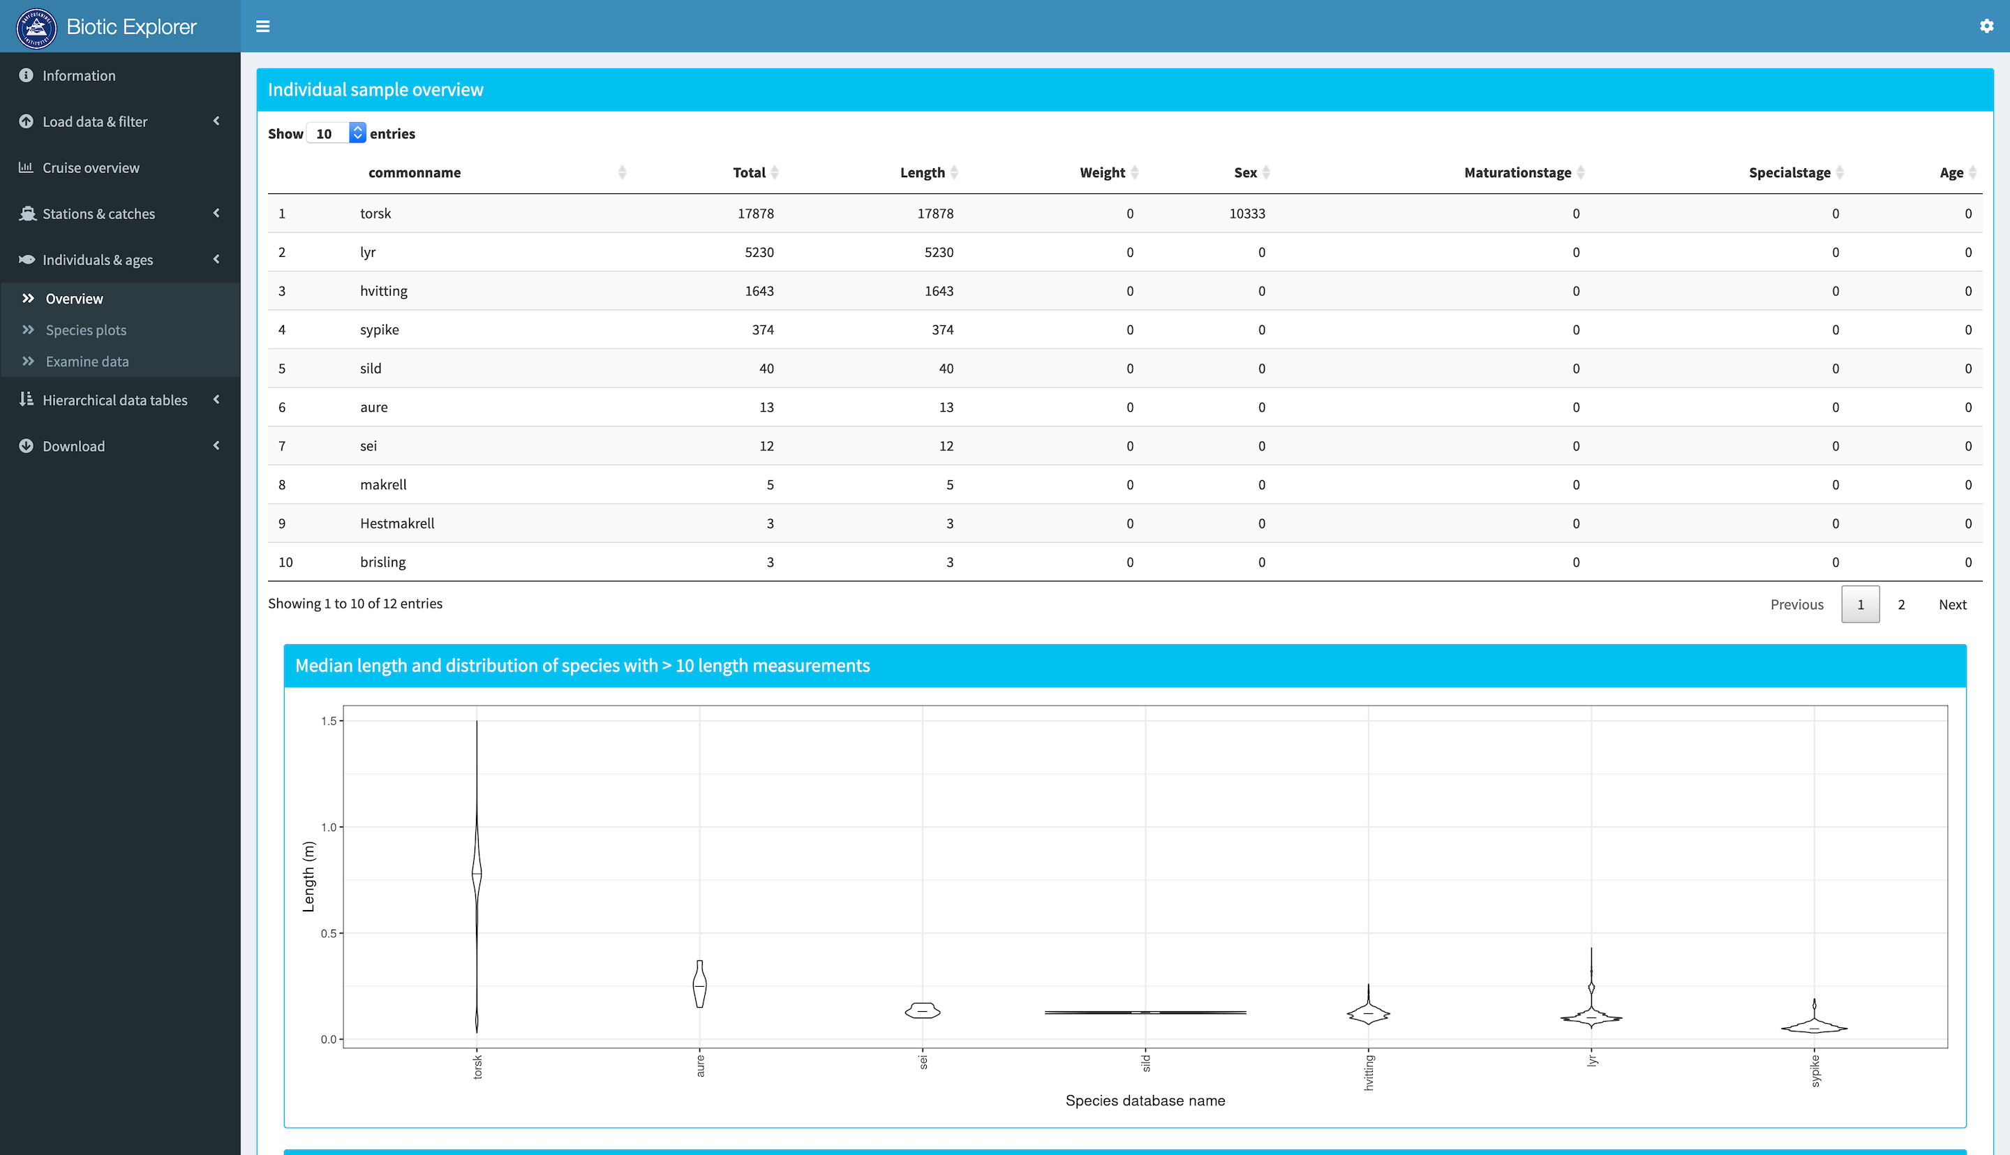 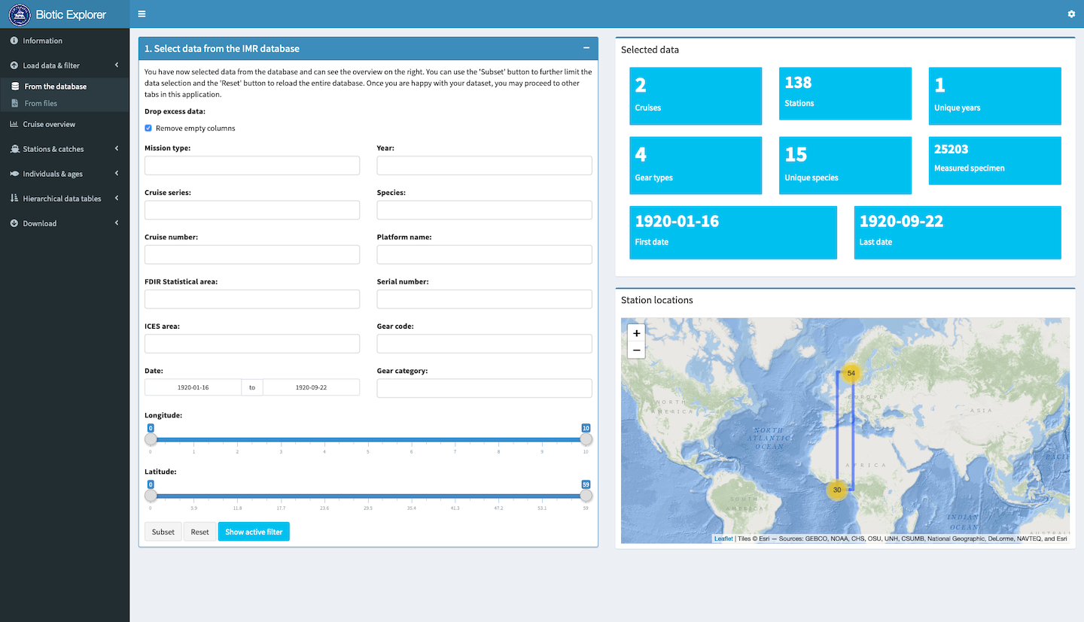

## 2.2 Echosounder comparison tool

*Ibrahim Umar (IMR), Espen Johnsen (IMR)*

*2017-11-28*

An R package to visually check and compare multiple echosounder data from different sources (NMD, CES, BEI, etc.) that are coming from the same cruise.

**License**: LGPL3

**URL** (*software*): <https://github.com/REDUS-IMR/REDUSnmdqeval>

**Keywords**: *IMR, R, NMD, echosounder, acoustic, cruise, compare*

**Screenshots**:

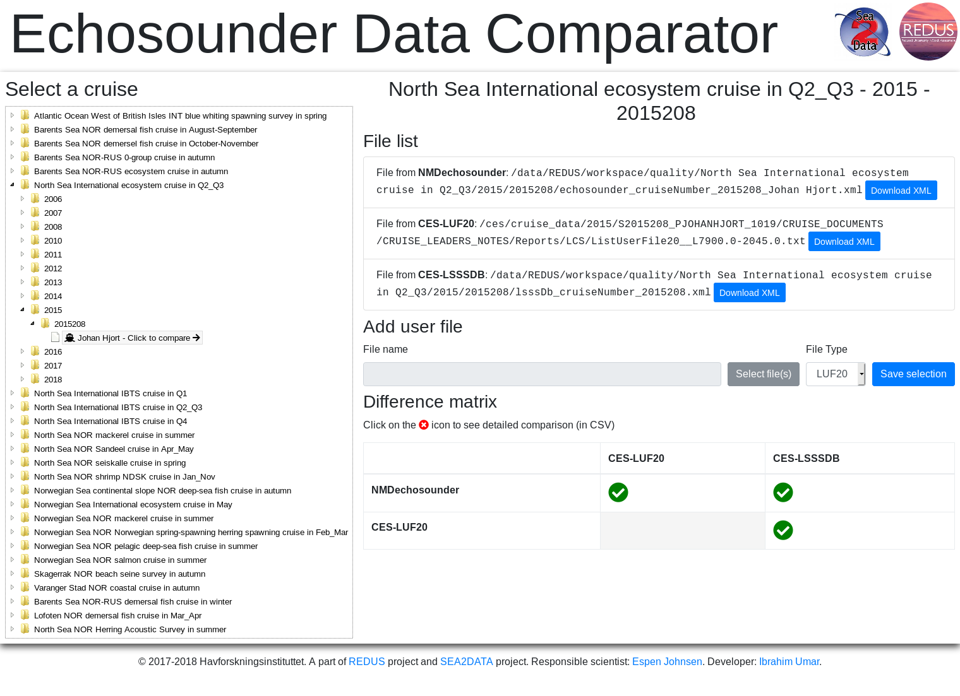

Screenshot1

## 2.3 Python EchoTools

*Ibrahim Umar (IMR), Sindre Vatnehol (IMR), Nils Olav Handegard (IMR)*

*2018-10-24*

A collection of Python scripts that can help in organizing all of the IMR’s acoustic raw data and LSSS databases. This tools also supports an automatic batch processing of the raw data to produce LUF20 reports by utilizing LSSS application.

**License**: LGPL3

**URL** (*software*): <https://github.com/REDUS-IMR/EchoTools>

**Keywords**: *acoustic, echosounder, python, IMR, REDUS, convert, organize, LUF20, SIMRAD, LSSS*

## 2.4 RstoxData

*Ibrahim Umar (IMR), Arne Johannes Holmin (IMR), Edvin Fuglebakk (IMR), Sindre Vatnehol (IMR), Espen Johnsen (IMR)*

*2019-03-03*

Set of tools to read and manipulate various data formats for fisheries. Mainly catered towards scientific trawl survey sampling (‘biotic’) data, acoustic trawl data, and commercial fishing catch (‘landings’) data. Among the supported data formats are the data products from the Norwegian Institute Marine Research (‘IMR’) and the International Council for the Exploration of the Sea (ICES).

**License**: LGPL3

**Jupyter notebook**: ([show](https://nbviewer.jupyter.org/urls/redus-imr.github.io/codes/assets/ibrahim-RstoxData.ipynb)) ([download](assets/ibrahim-RstoxData.ipynb))

**URL** (*software*): <https://github.com/StoXProject/RstoxData>

**Keywords**: *data, fisheries, biotic, acoustic, landings, ICES, reader, XML, REDUS, IMR*

## 2.5 Survey time series tools

*Ibrahim Umar (IMR)*

*2019-11-22*

An R package containing survey time series tools. One tool in the package enables users to download a complete StoX’s survey time series project (StoX project file + biotic data + acoustic data). A drop-in replacement of the deprecated NMD datasetexplorer’s ZIP download feature. Another tool enables users to check if their own survey time series’ StoX project XML file is correct (i.e., can be processed and produces official estimates) or not.

**License**: LGPL3

**URL** (*software*): <https://github.com/REDUS-IMR/stsdownloader>

**Keywords**: *survey time series, IMR, REDUS, download, zip, check, estimates*

**Screenshots**:

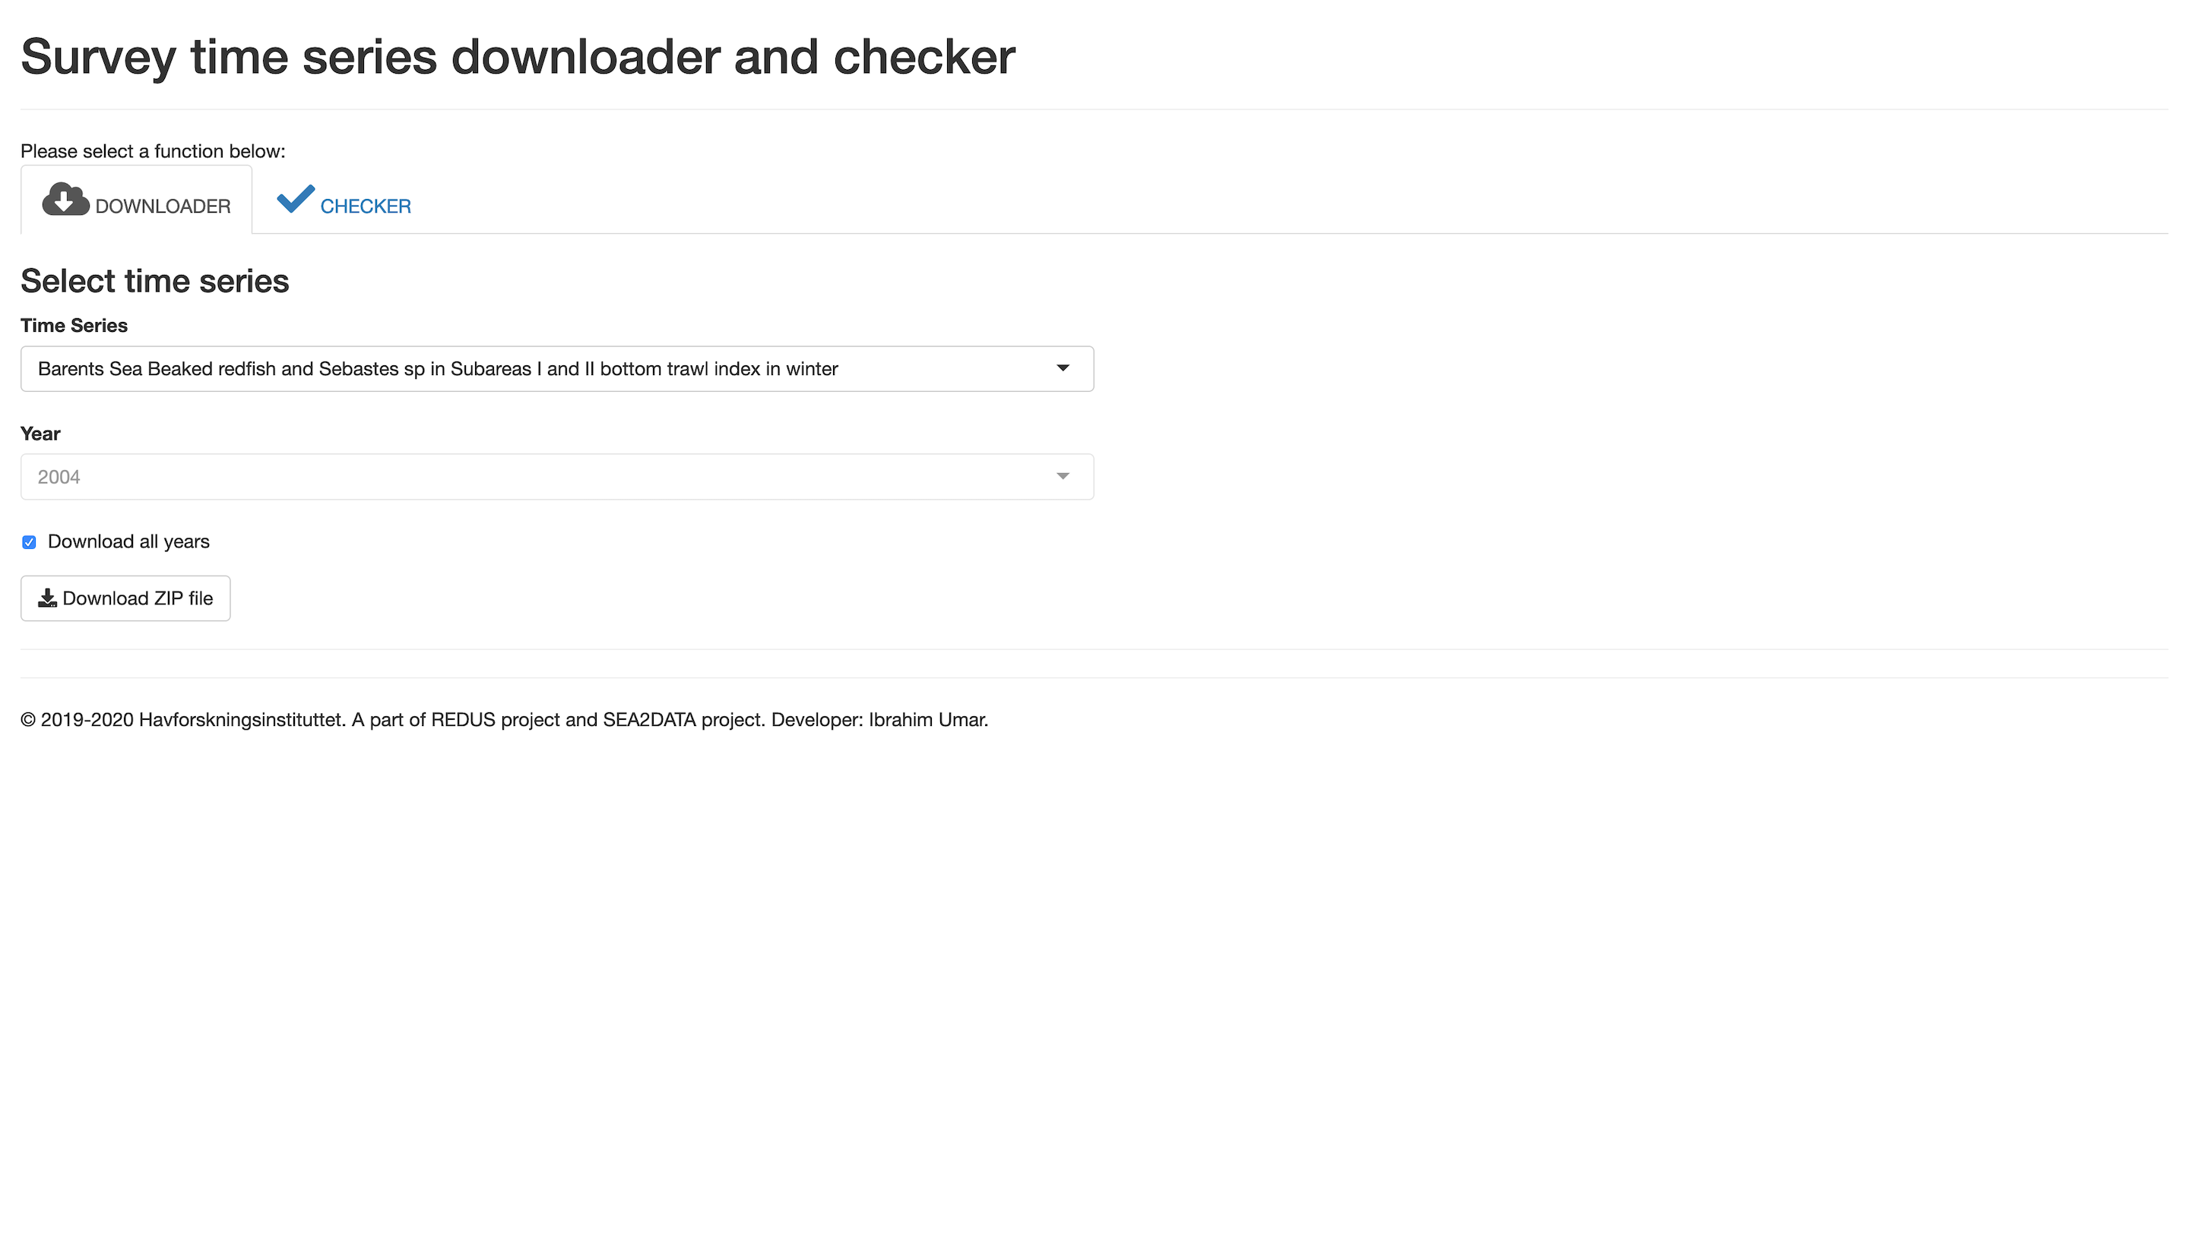 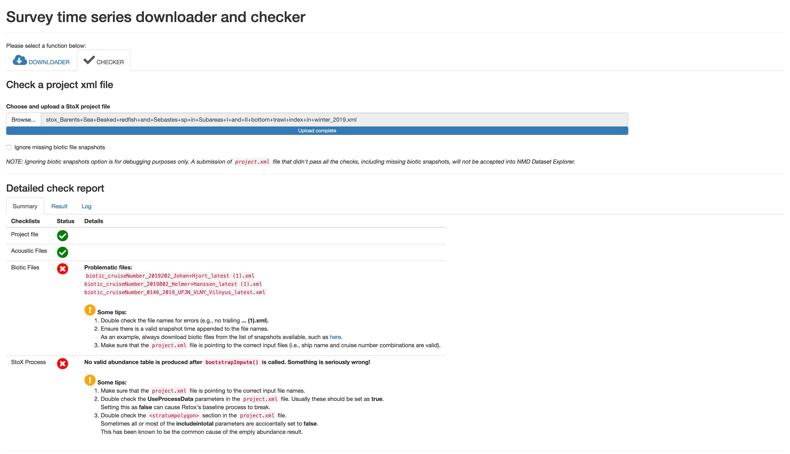

## 2.6 Various useful snippets

*Ibrahim Umar (IMR)*

*2020-12-31*

This is a collection of some scripts that can be useful for processing the IMR biotic data version 3 using R program. One script is for downloading a whole cruise and flattening the tables into one big table, while another one is for adding the missing scientific names for all the samples

**Jupyter notebook**: ([show](https://nbviewer.jupyter.org/urls/redus-imr.github.io/codes/assets/ibrahim-various_scripts.ipynb)) ([download](assets/ibrahim-various_scripts.ipynb))

**Download** (*software*): [ibrahim-various_scripts.R](./assets/ibrahim-various_scripts.R)

**Keywords**: *scripts, biotic, REDUS, IMR*

## 2.7 Trawl Performance Report

*Melanie Underwood (IMR)*

*2020-12-05*

Program that reads the trawl sensors data (Scanmar data and toktlogger REF files) to create a report. The report gives insights on when a trawl is performing correctly or when there is something that needs to be looked into further (i.e., opening height is too low/high or the trawl did not have good bottom contact, etc).

**License**: LGPL2

**URL** (*software*): <https://github.com/Mel-Underwood/Trawl-Preformance-Report>

**Keywords**: *trawl, scanmar, toktlogger, sensors, report, performance, REDUS, IMR*

**Screenshots**:

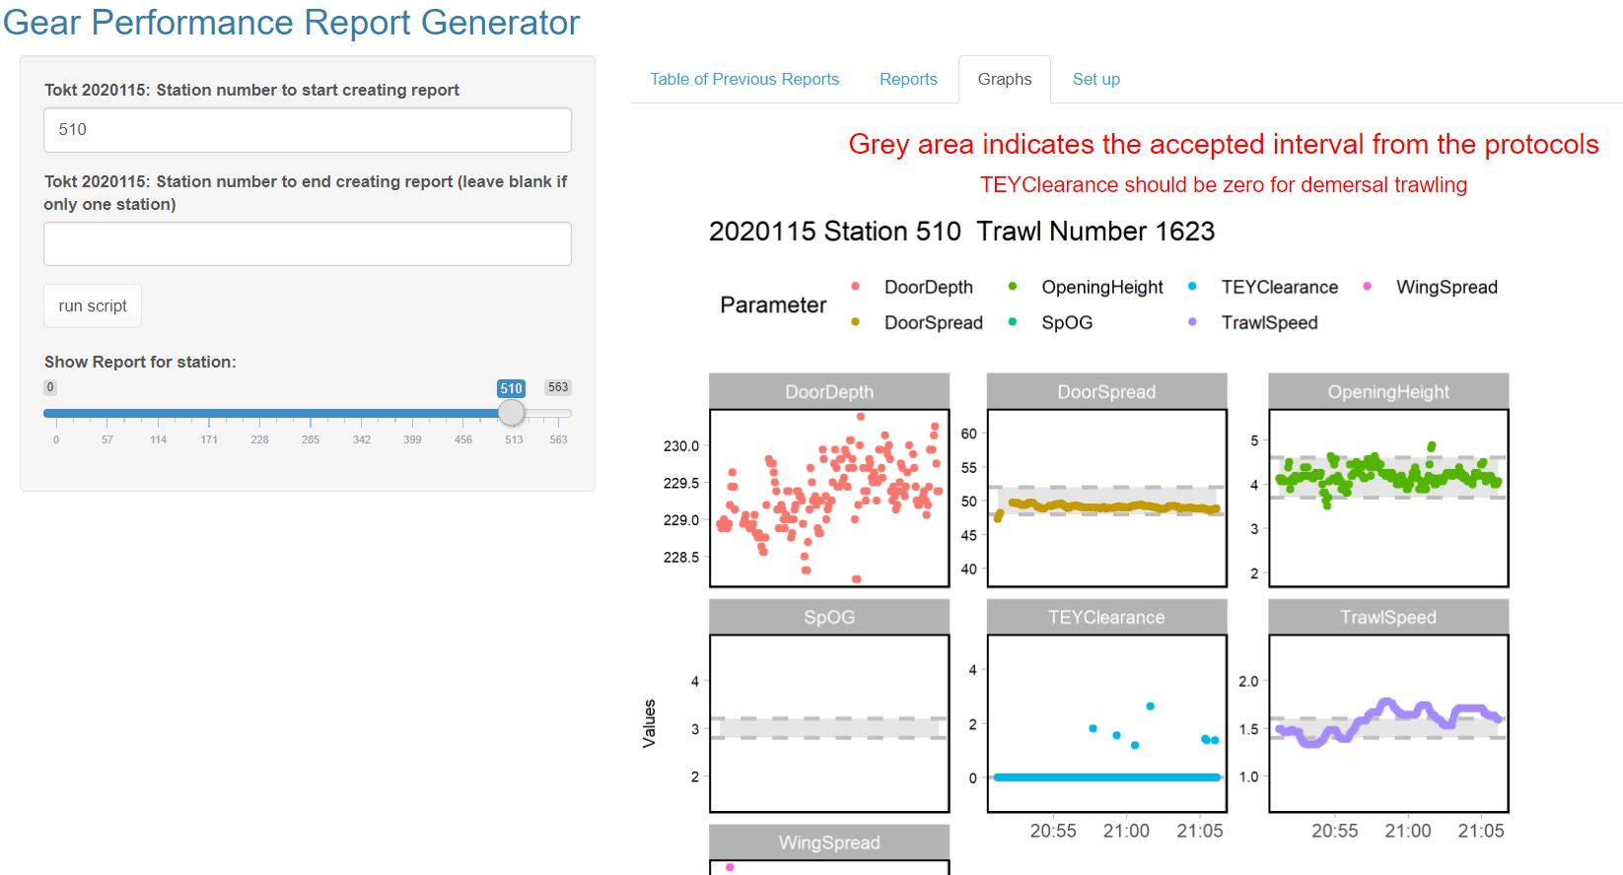 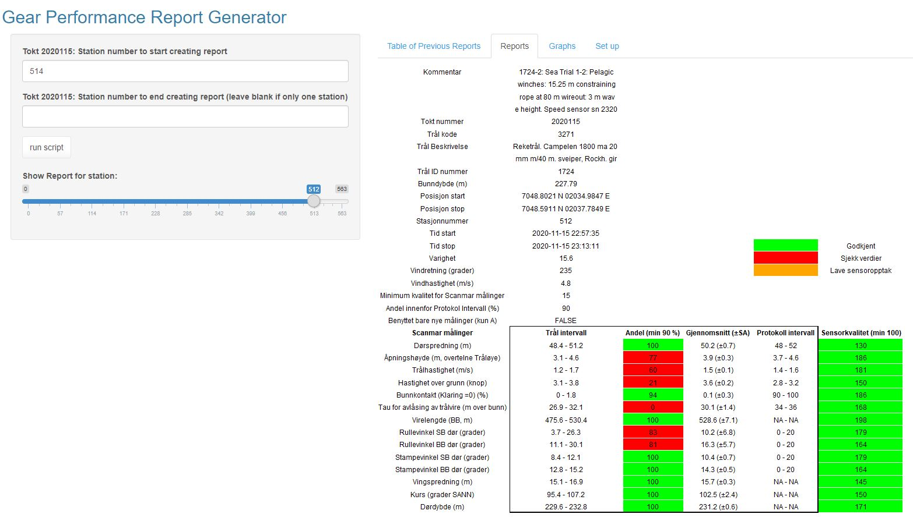 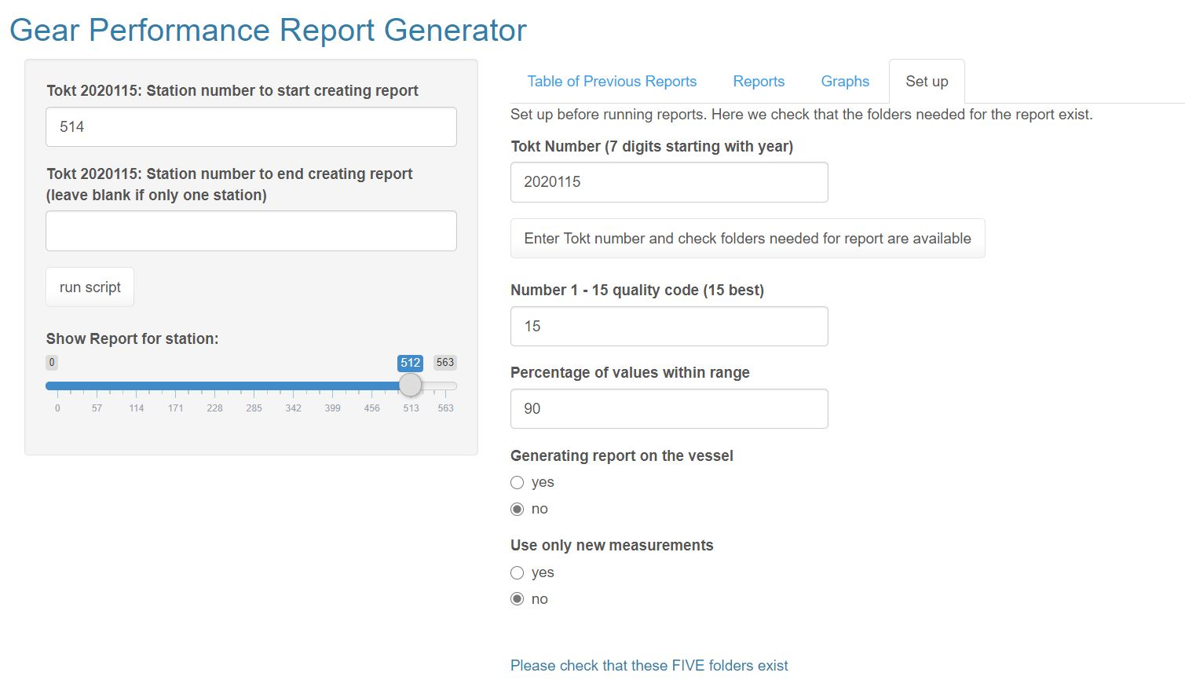 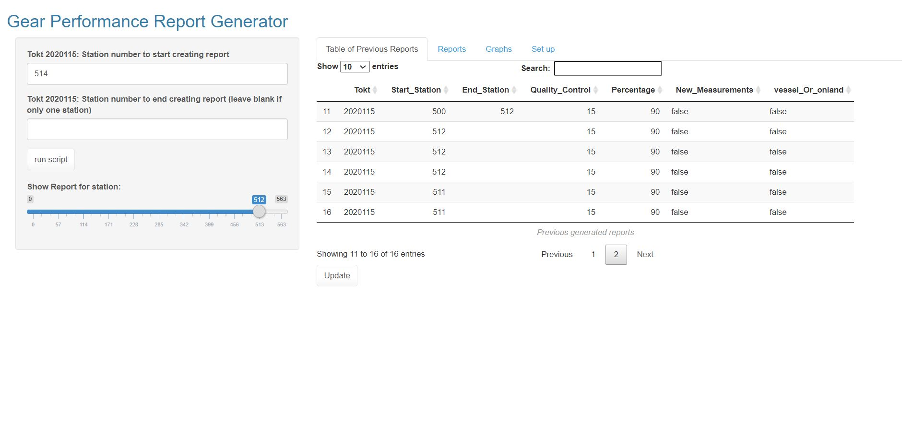 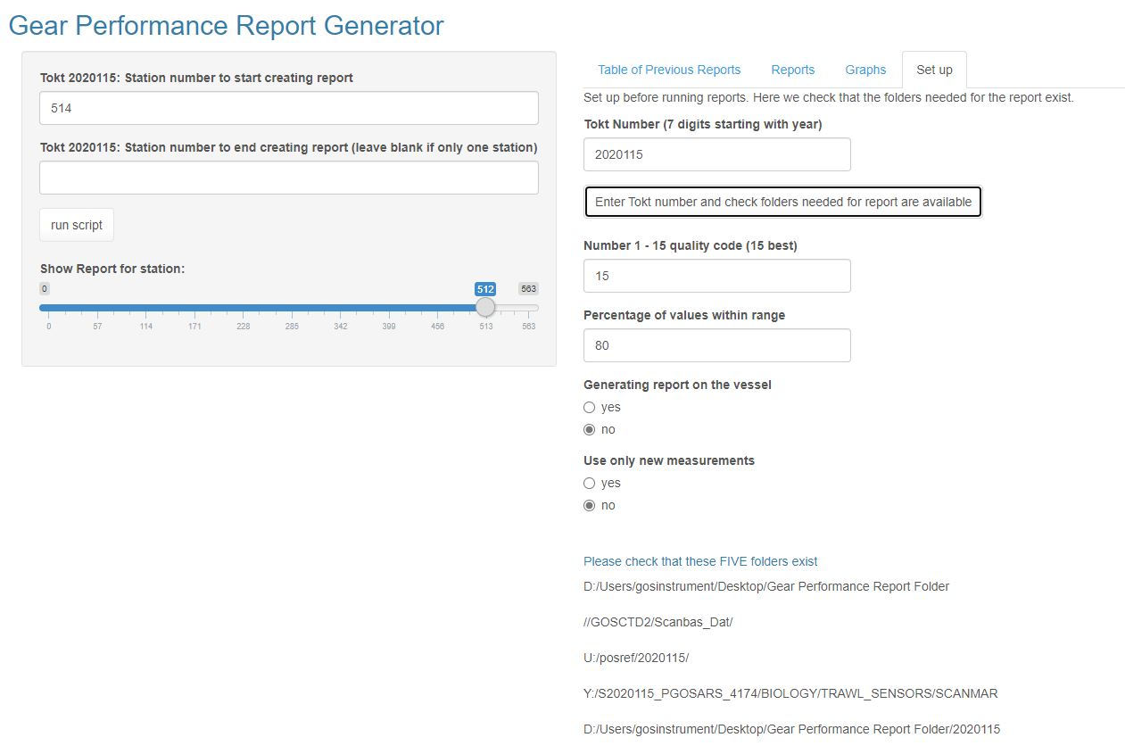

## 2.8 IBTSNorthSea: sampling strategies for age determination of cod (Gadhus morhua)

*Natoya O.A.S. Jourdain (IMR), Olav N. Breivik (NR) and Edvin Fuglebakk (IMR)*

*2019-02-20*

The North Sea cod stock assessment is based on indices of abundance-at-age from fishery-independent bottom trawl surveys. The age structure of the catch is estimated by sampling fish for otoliths collection in a length-stratified manner from trawl hauls. Since age determination of fish is costly and time consuming, only a fraction of fish is sampled for age from a larger sample of the length distribution and an age–length key (ALK) is then used to obtain the age distribution. In this study, we evaluate ALK estimators for calculating the indices of abundance-at-age, with and without the assumption of constant age–length structures over relatively large areas. We show that the ALK estimators give similar point estimates of abundance-at-age and yield similar performance with respect to precision. We also quantify the uncertainty of indices of abundance and examine the effect of reducing the number of fish sampled for age determination on precision. For various subsampling strategies of otoliths collection, we show that one fish per 5-cm-length group width per trawl haul is sufficient and the total number of fish subsampled for age from trawl surveys could be reduced by at least half (50%) without appreciable loss in precision.

**Jupyter notebook**: ([show](https://nbviewer.jupyter.org/urls/redus-imr.github.io/codes/assets/natoya-ibts.ipynb)) ([download](assets/natoya-ibts.ipynb))

**URL** (*software*): <https://github.com/NatoyaJourdain/IBTSNorthSea>

**Related identifiers**: <https://doi.org/10.1093/icesjms/fsaa013>

# 3 Work Package 3: Evaluating and testing of long-term management strategies

## 3.1 Evaluating the utility of a Novel Harvest Control Rule in the management of long-lived sporadically recruiting species through Management Strategy Evaluation

*Cian Kelly (UiB), Mikko Heino (UiB), Daniel Howell (IMR)*

*2019-08-16*

The code for the masters thesis work with the above title. Contains a Novel HCR, which reflected an Escapement HCR, was tested on a stock whose dynamics was informed by Greenland halibut (Reinhardtius hippoglossoides). The code is implemented as a modification of the FLBEIA software (<https://github.com/flr/FLBEIA>).

**Download** (*software*): [cian-flbeia_alternative.zip](./assets/cian-flbeia_alternative.zip)

**Related identifiers**: <https://bora.uib.no/bora-xmlui/handle/1956/20734>

## 3.2 Ecological effects and ecosystem shifts caused by mass mortality events on early life stages of fish

*Holly Perryman (IMR;* [*https://orcid.org/0000-0001-9341-682X*](https://orcid.org/0000-0001-9341-682X)*), and Ina Nilson (University of Bergen/IMR)*

*2019-11-06*

The following deposition contains scripts for creating the figures in Olsen et al. (2019). This deposition includes example files for executing the code. The files are inputs and outputs to/from the Norwegian and Barents Seas Atlantis model.

**Jupyter notebook**: ([show](https://nbviewer.jupyter.org/urls/redus-imr.github.io/codes/assets/holly-MMEmanuscript477196.ipynb)) ([download](assets/holly-MMEmanuscript477196.ipynb))

**Download** (*software*): [holly-MMEmanuscript477196.R](./assets/holly-MMEmanuscript477196.R)

**Related identifiers**: <https://doi.org/10.3389/fmars.2019.00669>

**References**: Olsen, E., Eide, C.H., Nilsen, I., Perryman, H.A. and Vikebø, F., 2019. Ecological effects and ecosystem shifts caused by mass mortality events on early life stages of fish. Frontiers in Marine Science, 6, p.669.

**Keywords**: *Atlantis; marine ecosystem model; data processing; biomass trends; spider plots*

## 3.3 Atlantis-R interface

*Ibrahim Umar (IMR), Holly Perryman (IMR), Rebecca Gorton (CSIRO), Elizabeth A. Fulton (CSIRO)*

*2019-10-24*

The marine ecosystem model Atlantis is structured following the MSE framework, meaning Atlantis simulates both the operating model and the management procedure. This is an advantageous feature for simulating MSE under and ecosystem-based context, however it may be cumbersome to program complicated/specific management procedures into Atlantis. To integrate Atlantis into the REDUS framework, Atlantis was programmed to send/receive data back and forth with the statistical software R. With this new functionality, Atlantis can be treated solely as an operating model while R is used to simulate the management procedure. Thus, management procedures previously programmed in R can now be simulated under an ecosystem-based context within Atlantis.

**License**: LGPL3 + CSIRO-proprietary

**URL** (*software*): <https://git.imr.no/REDUS/atlantis-code>

**Keywords**: *ecosystem, MSE, simulation, C, marine, box, model, multi-species, biogeochemical, physical*

## 3.4 GadgetR

*Ibrahim Umar (IMR), Bjarki Thor Elvarsson (Hafro), James Begley (Hafro), Hoskuldur Bjornsson (Hafro), Gunnar Stefnasson (Hafro), Lorna Taylor (Hafro), Daniel Howell (IMR), Sigurdur Hannesson (Hafro), Narfi Stefansson (Hafro), Hersir Sigurgeirsson (Hafro), Morten Nygard Asnes (IMR), Kristin Froysa (IMR), Audbjorg Jakobsdottir (Hafro), Jon Gudmundsson (Hafro), Gudmundur Einarsson (Hafro), Thordis Linda Thorarinsdottir (Hafro), Kristjana Yr Jonsdottir (Hafro), Mark G. Johnson (US-EPA), Bill Goffe (USM)*

*2018-06-21*

GadgetR is an R library that allows users to create a two-way interface to the simulation function (via a “gadget -s” command line switch) of Hafro’s Globally applicable Area Disaggregated General Ecosystem Toolbox (Gadget) program. To simply put, GadgetR provides users flexibility to explicitly control gadget simulation steps, and inspect and modify (as needed) gadget internal objects (such as recruitment parameters, fleet consumption amount, among others) at any point in time during the simulation. These functionalities are especially useful when you want to use a gadget model as an operating model (single or multi- species) in existing management strategy (MSE) frameworks in R (FLR/mse or FLBEIA). GadgetR ships with the latest Gadget program (version 2.2.00-BETA) and retains all of the original Gadget program functionality.

**License**: GPL2

**URL** (*software*): <https://github.com/REDUS-IMR/gadget>

**Related identifiers**: <https://redus-imr.github.io/gadget/articles/quickstart.html>

**Keywords**: *simulation, optimization, multi-species, stock, gadget ecosystem, R, C++, MSE*

## 3.5 Multi Fleet Deterministic Projection (MFDP)

*Ibrahim Umar (IMR)*

*2020-12-18*

Program for the fisheries short-term prediction. Allows for multi-fleet catch constraints and multi-annual prediction. This program is an attempt to re-create the original Multi Fleet Deterministic Projection (MFDP) program for fisheries in R.

**License**: LGPL3

**Jupyter notebook**: ([show](https://nbviewer.jupyter.org/urls/redus-imr.github.io/codes/assets/ibrahim-mfdp.ipynb)) ([download](assets/ibrahim-mfdp.ipynb))

**URL** (*software*): <https://github.com/REDUS-IMR/mfdp>

**Keywords**: *mfdp, fisheries, forecast, multi-year, REDUS, IMR*

## 3.6 MSE Framework

*Ibrahim Umar (IMR), Daisuke Goto (IMR), Alfonso Perez Rodriguez (IMR)*

*2019-03-14*

FLR-Gadget is a Management Strategy Evaluation (MSE) framework using FLR (The Fisheries Library in R) mse (<https://github.com/flr/mse>) with an R package of customized Gadget (Globally applicable Area Disaggregated General Ecosystem Toolbox, <https://github.com/Hafro/gadget2>), GadgetR (<https://github.com/REDUS-IMR/gadget>), as an operating model (OM). This framework is designed to run single and multi- species MSEs. The OM can be age- or length- based. The framework runs short-cut and full-feedback MSEs. Currently, a4a (Assessment for All, <https://github.com/flr/FLa4a>) statistical catch-at-age model and SAM (State-space Assessment Model, <https://github.com/flr/FLSAM>) are implemented as an assessment model.

**License**: LGPL3

**Jupyter notebook**: ([show](https://nbviewer.jupyter.org/urls/redus-imr.github.io/codes/assets/ibrahim-MSE_framework.ipynb)) ([download](assets/ibrahim-MSE_framework.ipynb))

**URL** (*software*): <https://github.com/dgoto2/flr-gadget>

**Keywords**: *IMR, REDUS, FLR, MSE, multi-species, simulation, framework, R, fisheries, gadget*

## 3.7 mse-bootstrap-gcp

*Ibrahim Umar (IMR), Jennifer Devine (IMR), Daisuke Goto (IMR)*

*2019-02-24*

Scripts for running the North Sea Saithe Management Strategy Evaluation (MSE) on Google Cloud Platform (GCP)

**License**: LGPL3

**URL** (*software*): <https://github.com/REDUS-IMR/mse-bootstrap-gcp>

**Keywords**: *IMR, REDUS, bash, GCP, MSE, North Sea Saithe, simulation, parallel*

## 3.8 North Sea saithe Management Strategy Evaluation (MSE)

*Jennifer Devine (IMR), Daisuke Goto (IMR), Ibrahim Umar (IMR), Colin Millar (ICES), Jose De Oliveira (CEFAS), Simon Fischer (CEFAS)*

*2019-06-17*

A management strategy evaluation (MSE) framework for North Sea saithe (Pollachius virens) in Subareas 4, 6 and Division 3.a (North Sea, Rockall and West of Scotland, Skagerrak and Kattegat) developed using the Fisheries Library in R mse package as part of the Workshop on North Sea stocks Management Strategy Evaluation (WKNSMSE).

**URL** (*software*): <https://github.com/ices-taf/wk_WKNSMSE_pok.27.3a46>

**Related identifiers**: <https://doi.org/10.17895/ices.pub.5090>

**Keywords**: *mse, saithe, ices, north sea, R, FLR, REDUS, IMR*

# 4 Work Package 4: Communication of uncertainty, dissemination of project results and capacity building

## 4.1 Fishdocker

*Ibrahim Umar (IMR)*

*2018-10-03*

A collection of Dockerfile, or the recipe to create images that will be used inside a container (e.g., REDUS framework and portable Rstox images). This collection is an important element of the REDUS Assessment Frameowrk.

**License**: LGPL3

**URL** (*software*): <https://github.com/REDUS-IMR/fishdocker>

**Keywords**: *docker, podman, container, Rstox, REDUS*

## 4.2 REDUS Framework app

*Ibrahim Umar (IMR)*

*2019-06-17*

This repository contains the cloud-based REDUS framework’s backend and frontend systems.

The frontend provides user with the framework’s runtime configuration and control, as well as a set of “live” panels that connect directly into the framework’s docker machine. The current available panels are the file manager, console terminal, and log viewers. The frontend system uses Vue.js, Bootstrap + Vue, and axios HTTP client.

The backend system responsible for generating runtime configurations for the framework, creating docker machines and starting them, and providing http/websocket proxy tunnels to make file manager, console terminal, and log viewers available to the users. The backend system utilizes NodeJS, Docker, and Docker Machine.

**License**: LGPL3

**URL** (*software*): <https://github.com/REDUS-IMR/redus-framework>

**Keywords**: *redus, framework, assessment, taf, nodejs, html, docker, podman, gui, frontend, backend*

**Screenshots**:

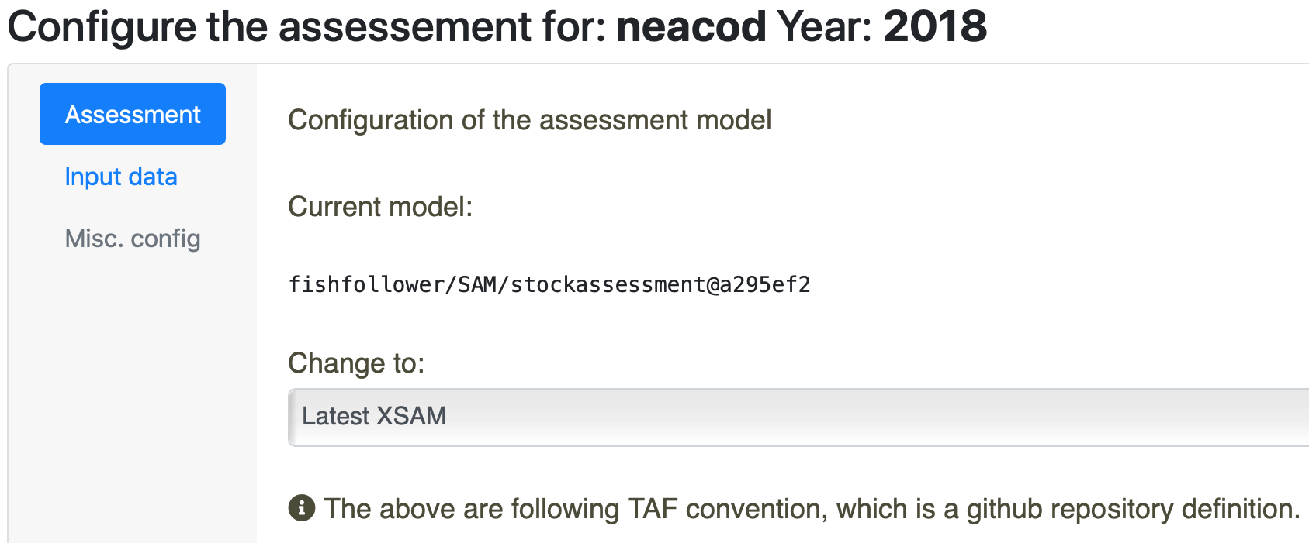 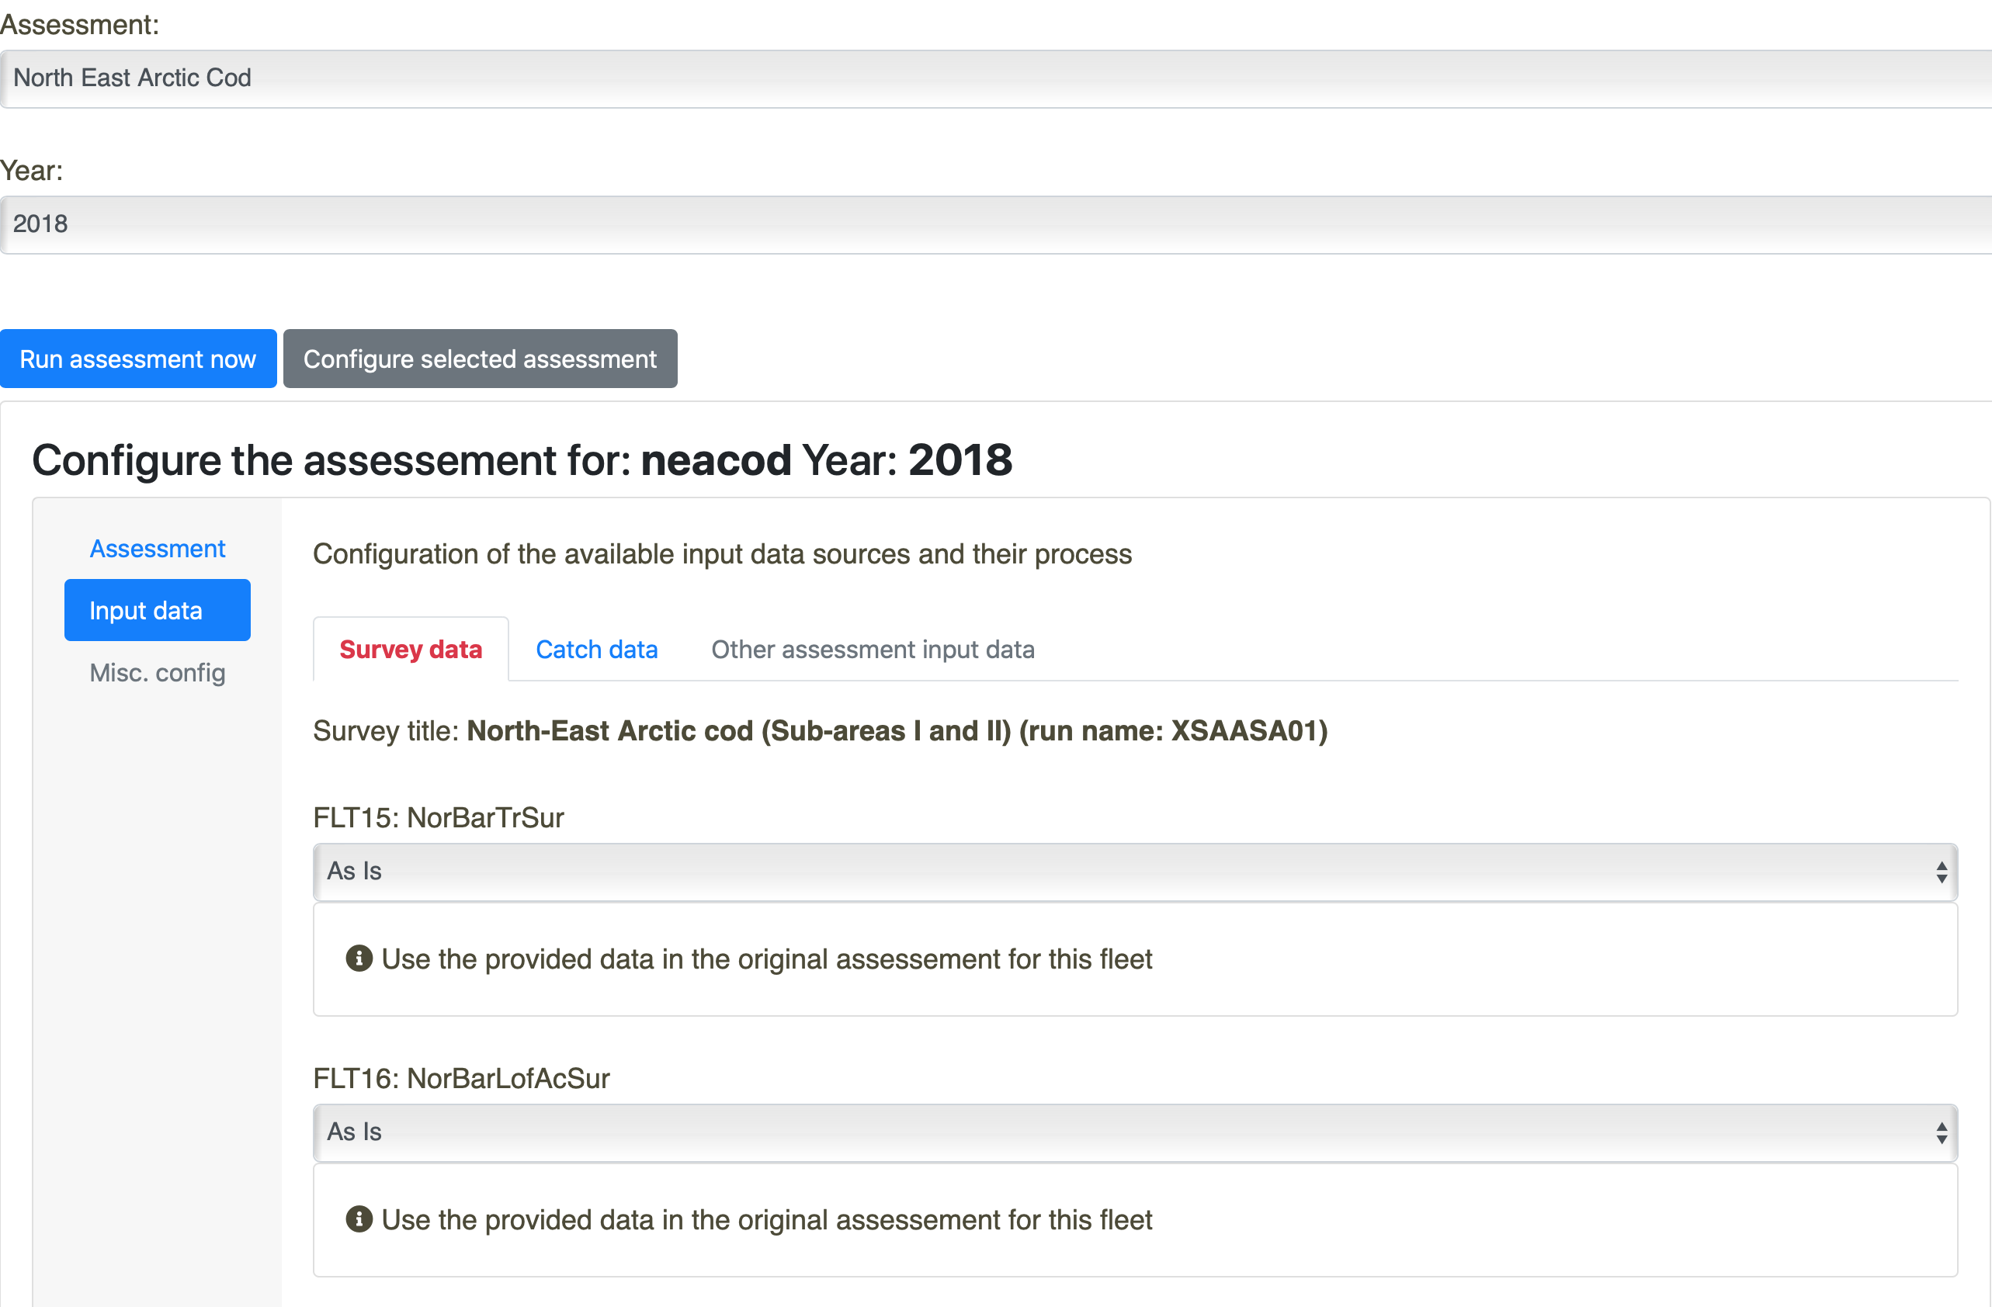 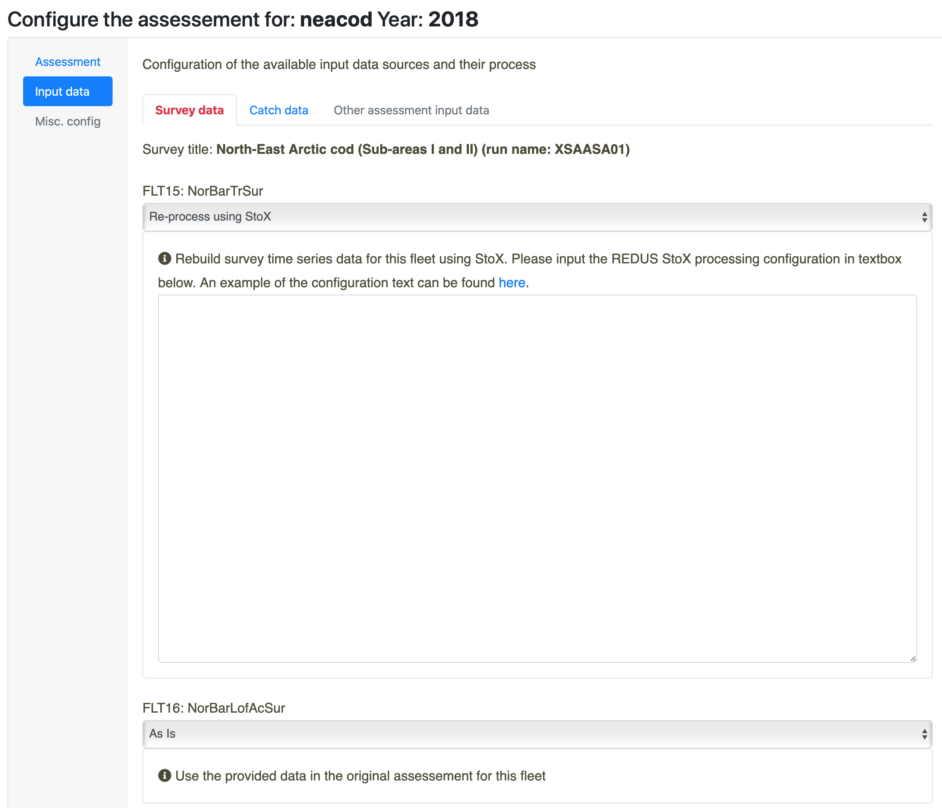 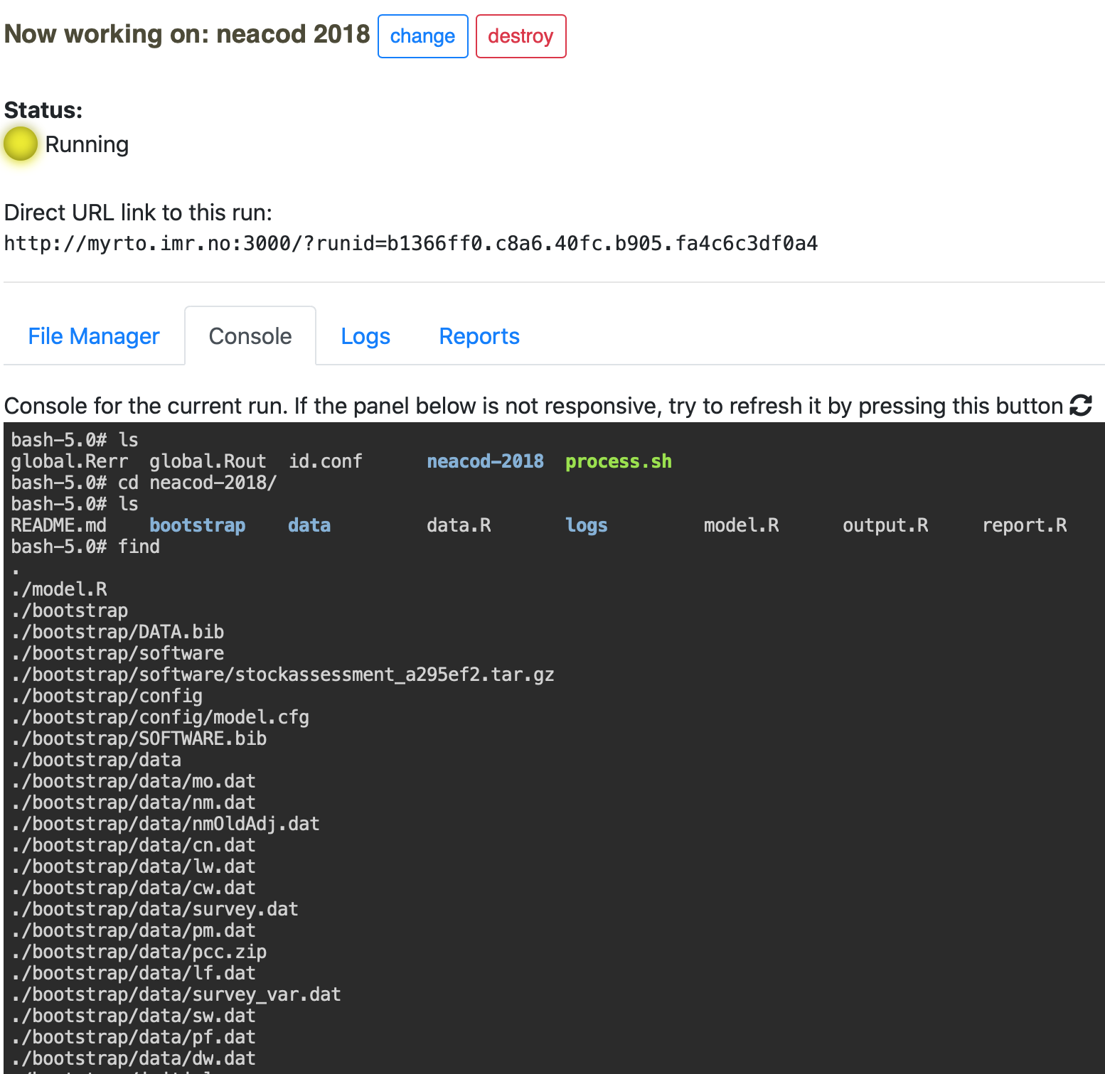 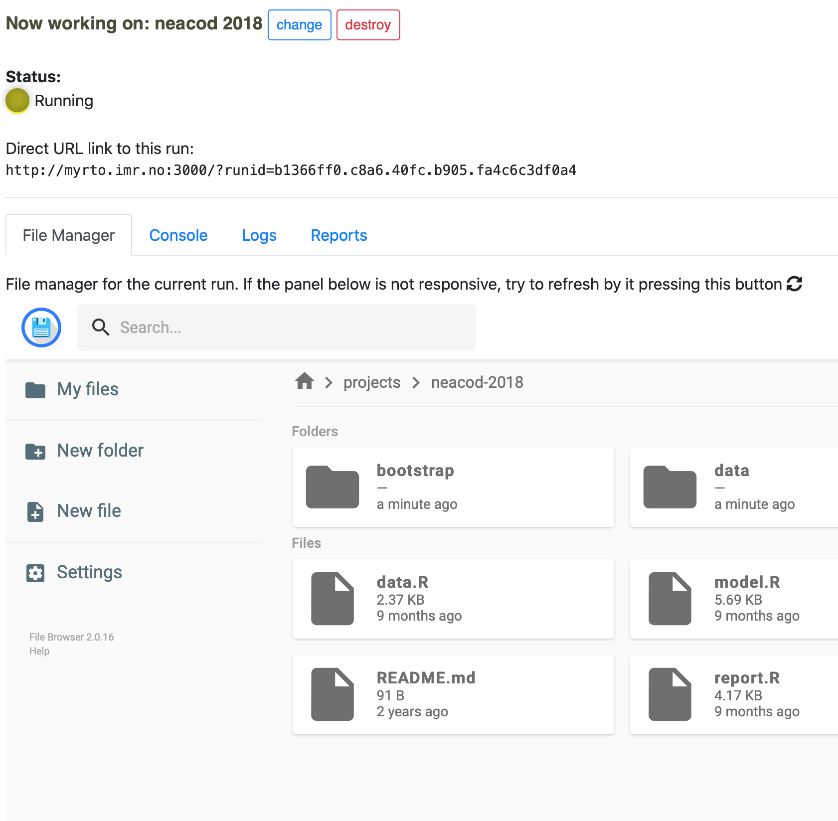 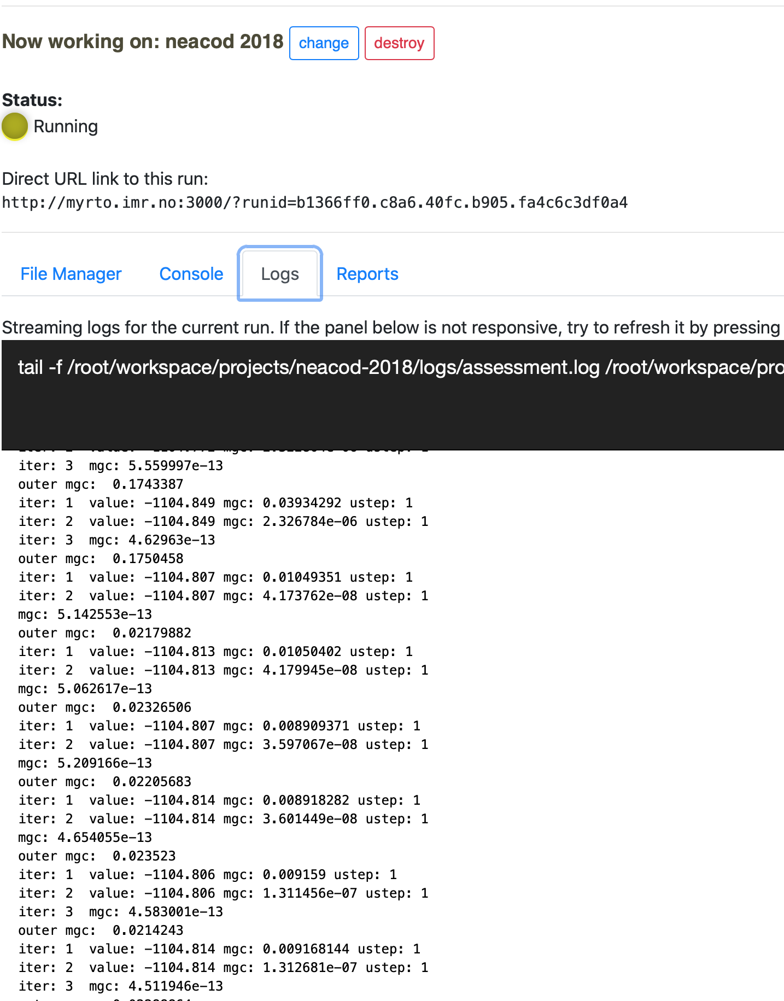 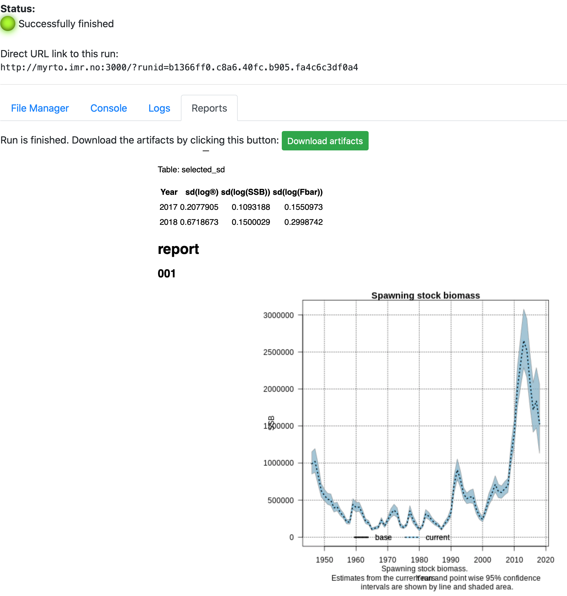 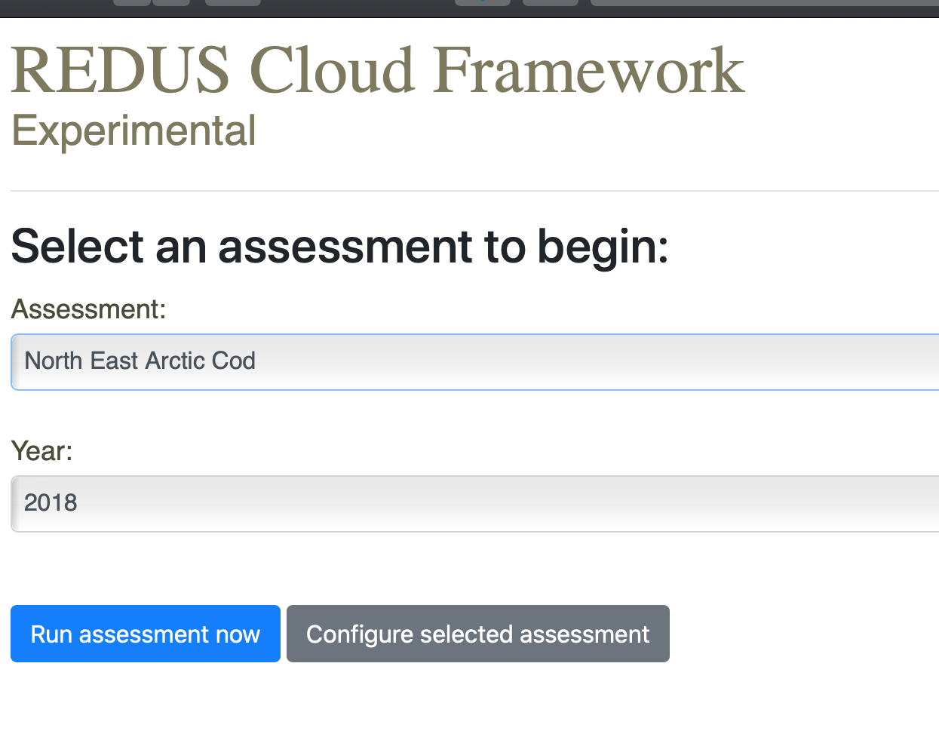 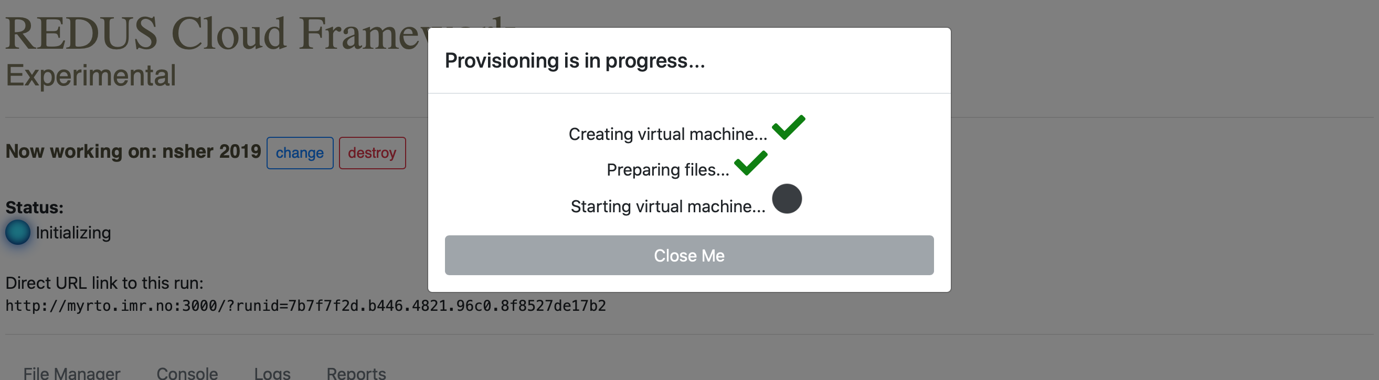

## 4.3 REDUStools

*Ibrahim Umar (IMR)*

*2018-12-03*

REDUStools is an R package (source) that can periodically process all the available IMR survey time series and store the results in file-backed database in the server. REDUStools also provides APIs for getting the survey time series results and gives users two sets of front-ends to explore the stored results. This package is the important piece of code for the REDUS Assessment Framework.

**License**: LGPL3

**URL** (*software*): <https://github.com/REDUS-IMR/REDUStools>

**Keywords**: *REDUS, API, RstoX, estimates, survey, processing, R, covariance*

**Screenshots**:

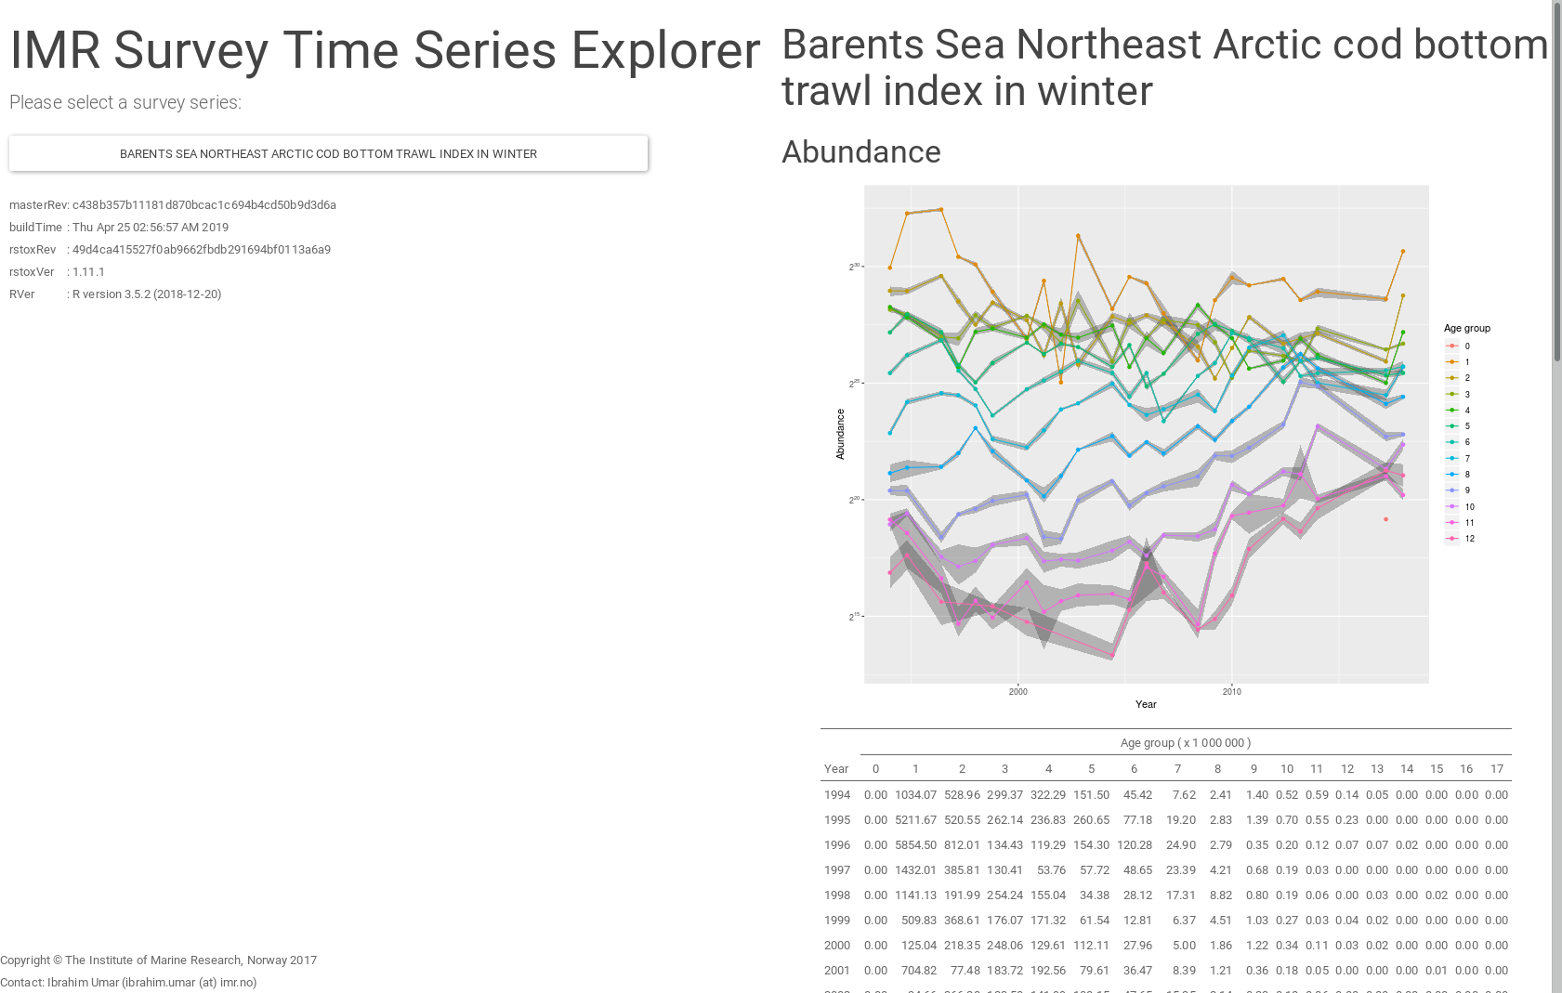 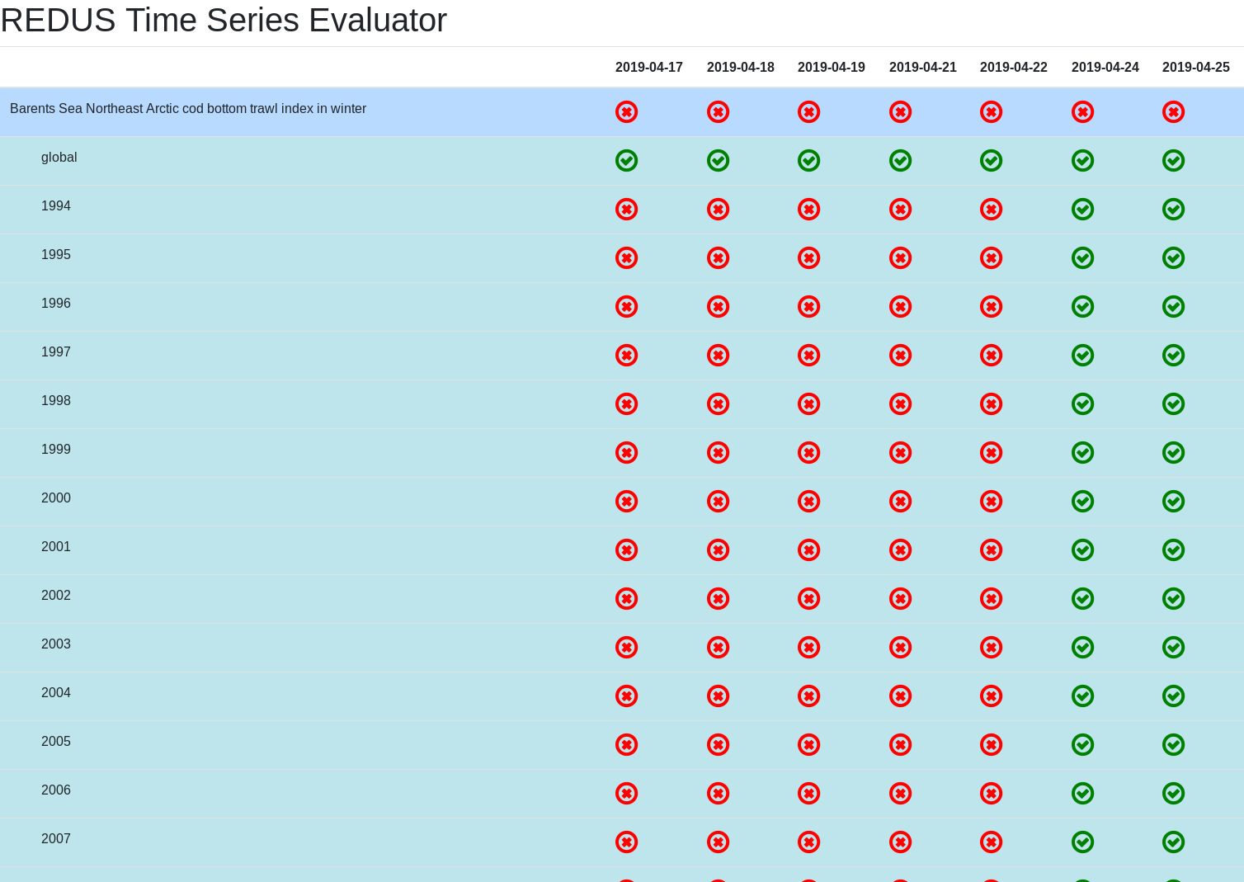

## 4.4 SAM-course

*Olav Nikolai Breivik, Sindre Vatnahol and Knut Korsbrekke*

*2019-10-01*

SAM-course held at IMR

**URL** (*software*): <https://github.com/OlavNikolaiBreivik/AssassmentCourse>

## 4.5 TMB courses

*Hans Julius Skaug (UIB/HI), Olav Nikolai Breivik (NR) and Jens Christian Wahl*

*2018-04-30*

TMB course held at IMR

**URL** (*software*): <https://github.com/skaug/tmb-case-studies>